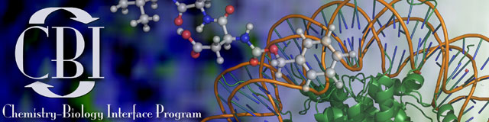
CBI Program Member Application (save & resubmit with updated info circled)

Name: | Faculty Advisor:
Email Address: | Phone Number:
Student ID Number: | Academic Program:
Country of Citizenship: | Academic Program Begin Date:
Date of Birth: | Anticipated Graduation Date:
NIH requests this information if individuals are willing to self-report (for more information, please visit http://grants.nih.gov/grants/guide/pa-files/PA-14-015.html):
Race/Ethnicity: Do you have a disability? Yes No
Gender: Female Male Transgender Non-Binary
Do you come from a family with an annual income below established low-income thresholds according to http://aspe.hhs.gov/poverty/index.shtml? Yes No

Previous Training
Undergrad Institution: |  |  | Major: |  | Degree: |  | Year: | GPA:
Grad Institution: |  |  | Major: |  | Degree: |  | Year: | GPA:
GRE Scores | Verbal: | Quantitative: |  | Analytical: |  | GRE Not Taken

CBI Required Coursework
Visit https://cbi.chem.umass.edu/courses/curriculum-overview/ for the curriculum requirements and list of electives.
Quantitative Training – For Chemistry, Chem E, and PSE students this requirement is satisfied by your department curricula. For all others (eg MCB, Microbiology) CBI requires taking either Physical Chemistry during your undergraduate study, or Chem 471 during your graduate study at UMass:
Did you take Physical Chemistry during your undergraduate studies?
yes no
Did you take Chem 471 at UMass?
yes no
Chalk Talks – Chem 797 (min 4 semesters registered) | Drug Design – Chem/Biochem 597 (1 sem)
Number completed | Year taken
Student Seminar – Chem 791 (2 semesters) | Biological Sciences Elective (min 1 course)
Number completed | Class taken
Ethical Conduct – Chem 797 (1 semester) | Chemical Sciences Elective (min 1 course)
Year taken | Class taken

Annual Committee meetings information (dates, description) should be included

in CBI Progress Report starting from Year 2 of your program
Attach a one page description of your research, emphasizing how it relates to the Chemistry-Biology Interface. First-year students can omit this; please submit it with an updated Application by the start of your second year.
Signature: | Date:
Advisor’s Signature: | Date:

Please direct questions/submit form to cbiassist@umass.edu

