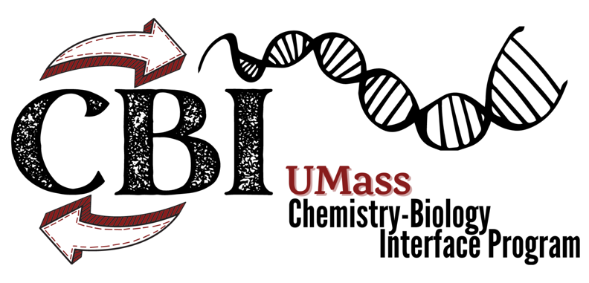
NIH Chemistry-Biology Interface
T32 Traineeship Application
Chemistry-Biology Interface Training Program Mission
The goal of the CBI program is to provide students with backgrounds in either chemistry or biology with the training they need to carry out research in areas that entail significant, inseparable contributions from both the chemical and biological sciences. The CBI curriculum prepares students for careers in biomedical research in the pharmaceutical and biotechnology industries and in academia. CBI also nucleates a community of CBI labs to promote interaction and collaboration that enhances training and research productivity. We encourage students who intend to complete the CBI curriculum and participate in CBI activities to become CBI members, regardless of traineeship funding.

Eligibility
To apply for a two-year CBI traineeship, students must be members of the CBI program and working in the lab of a CBI faculty member. Only U.S. citizens or permanent residents are eligible for the NIH-funded fellowships; all students, both domestic and international, are eligible for UMass-funded fellowships.

Apply
Return completed applications to:
Emma Jacobson
BTP/CBI Program Manager
cbiassist@umass.edu

Only electronic submissions are accepted. Application materials should be combined into a single pdf. A nomination letter from the advisor and another letter of recommendation should be sent directly to cbiassist@umass.edu.
Complete the application below, and submit as a single pdf with:
CBI Program Member Application (or updated application if you are already a member)
Transcripts: Undergraduate and Graduate
One-page summary of your research, emphasizing relevance to the interface between chemistry and biology.

Writers of two nomination letters should email letters directly to cbiassist@umass.edu
Nomination letter from sponsoring CBI faculty/advisor
A second letter of recommendation from a UMass faculty member

student information
Name |  |  |  |  |  | Email |  |  |  |  |  | Student ID #
Street Address |  |  |  |  |  |  |  |  |  |  |  | Apartment/Unit #
City |  |  |  |  |  | State |  |  |  |  |  | ZIP
Home Phone |  |  |  |  |  | Lab Phone |  |  |  |  |  | Date of Birth
Citizenship | U.S. Citizen  Permanent Resident |  | International Student |  |  |  | What country do you hold citizenship status?
Race & Ethnicity | Black/African American Latino/Hispanic American Indian/Alaska Native Native Hawaiian/Pacific Islander Asian White

Current Academic information
UMass Graduate Dept/Program |  | Chemistry |  | Molecular & Cellular Biology |  |  |  |  |  |  | Microbiology
 |  | Chemical Eng. |  | Polymer Science & Engineering |  |  |  |  |  |  | Other, specify

2. Disclosure of Training support:

Have you ever been supported by other training support during your time as a graduate student at UMASS? Y N
If so, please list all of your training grant programs and date range. Student who are awarded a CBI traineeship may not be supported by other training grant as each training grant must be independent of other programs.
Program Name: |  |  |  |  |  |  |  | Year(s) in program (YYYY-YYYY):
Program Name: |  |  |  |  |  |  |  | Year(s) in program (YYYY-YYYY):

